# C3- S8 PRACTICE

# Flowchart to Boolean expression

Example

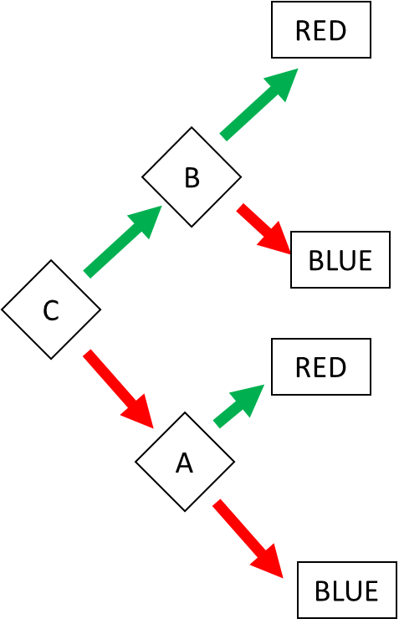

Answer:

RED = (C and B) or (!C and A)

BLUE = (C and !B) or (!C and !A)

# Ex 1: Find the Boolean expression of BLUE

BLUE = (A and B and !C) or (A and !B) or (!A and !D and B)

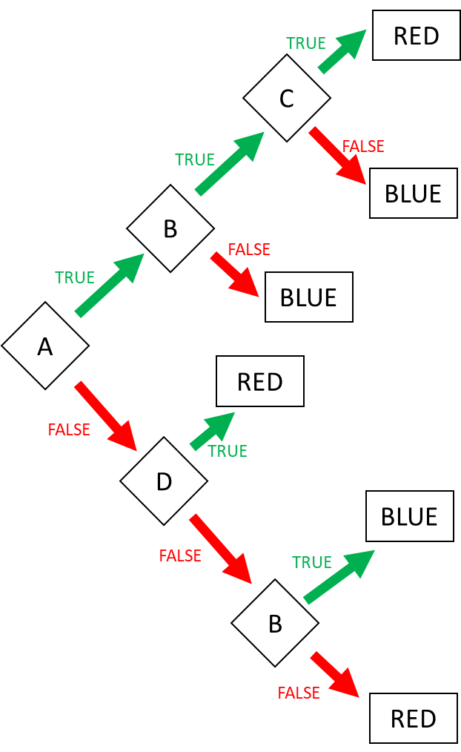

# Ex 2: Find the Boolean expression of BLUE

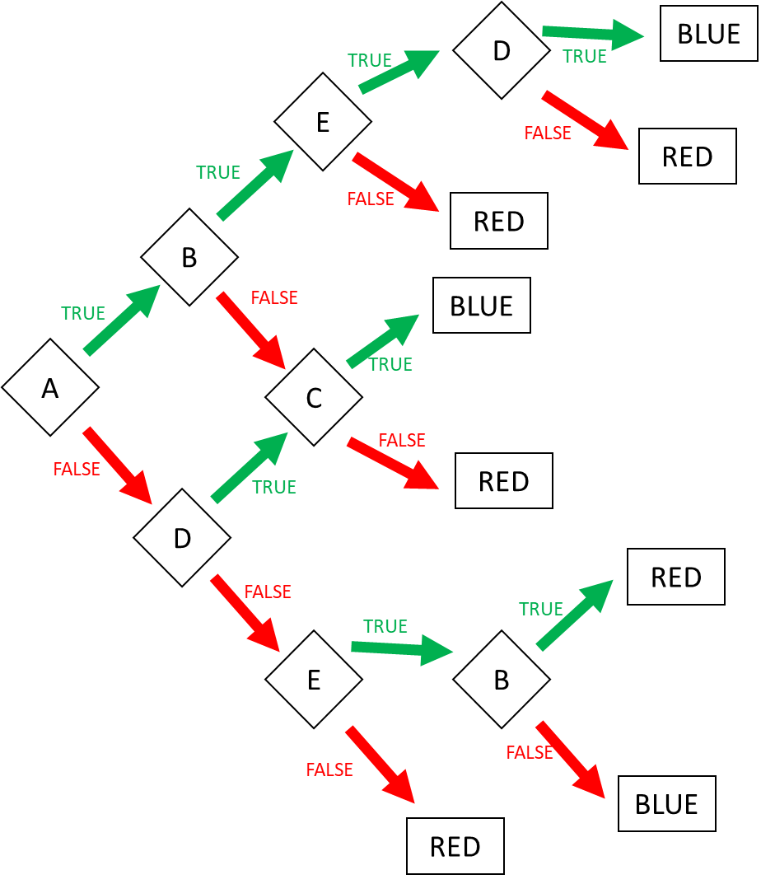

BLUE = (A and B and E and D) or (A and !B and C) or (!A and D and C) or (!A and !D and E and !B)

Ex 2: Create the flowchart according to the expressions (4 flowcharts):

1. Go to the market = AB or !A!C

Go to the market

B

Don’t go

A

Don’t go

C

Go to the market

1. Go to swim = ( Sunny AND Sunday) OR ( !(Sunny) and Monday and no homework)

Go to swim

Sunday

Can’t go

sunny

Go to swim

No homework

Can’t go

Monday

Can’t go

1. I’m superman = A!BCD or AB!CD or !ABCD

I’m not superman

C

I’m superman

D

B

C

A

B

I’m not superman

1. Happy = ABC!DE!F or A!BCD!EF or !ABCD!E or !A!BC

unhappy

Happy

unhappy

F

E

C

D

F

B

E

Happy

C

Happy

A

unhappy

E

D

unhappy

C

B

Happy

C

Happy

# 1D range colors

Example:

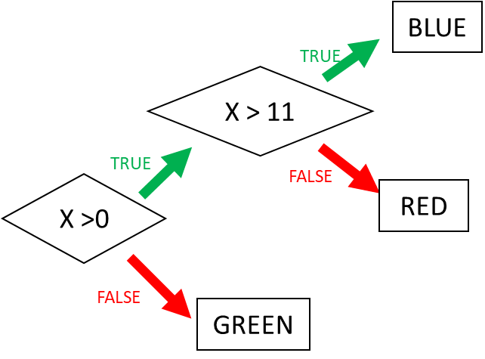

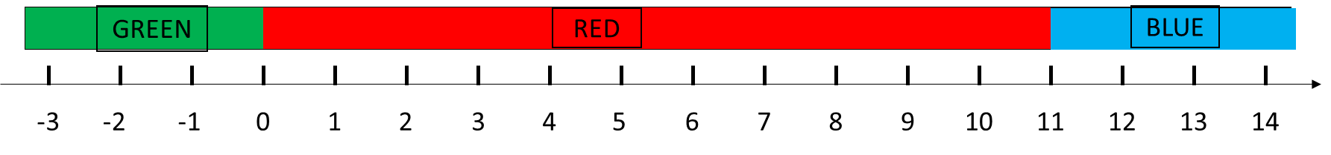

Ex 3: Ranges (1)

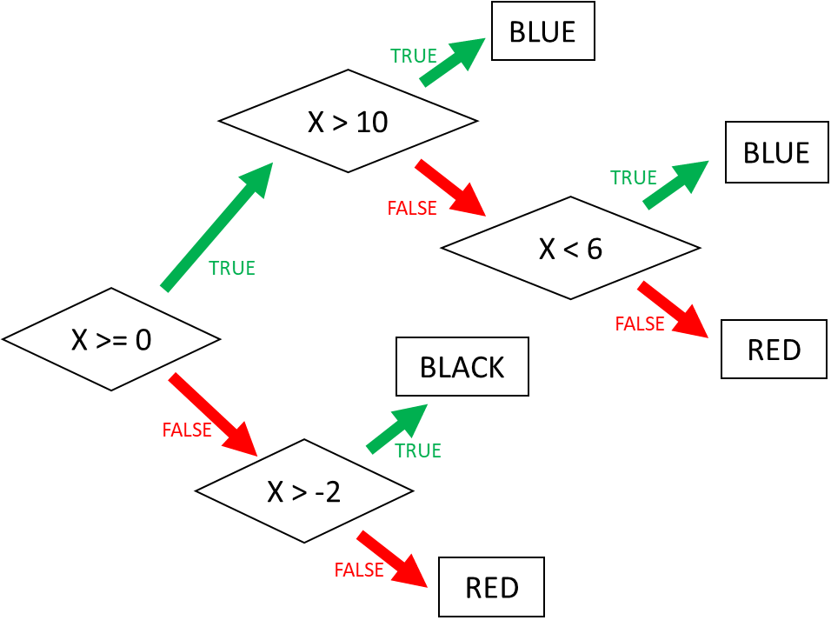

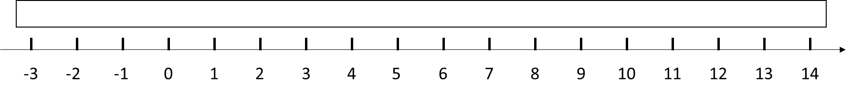

Ex 4: Ranges (2)

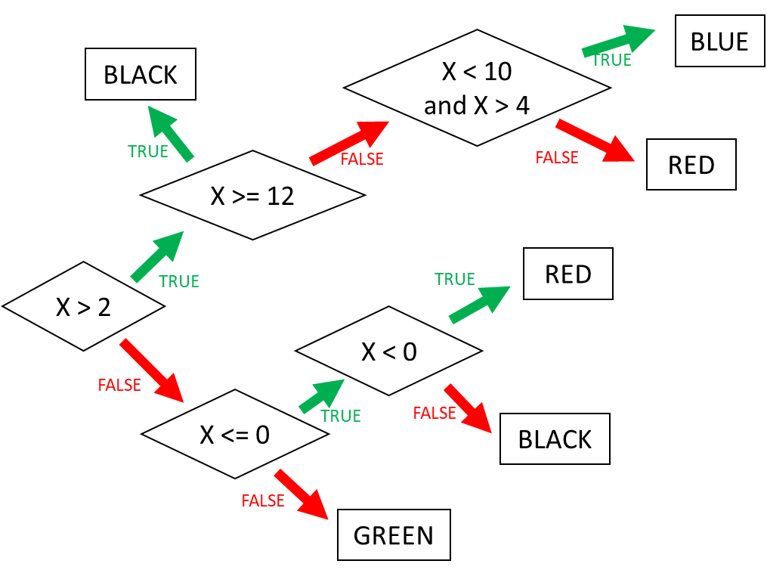



# 2D range colors

Example:

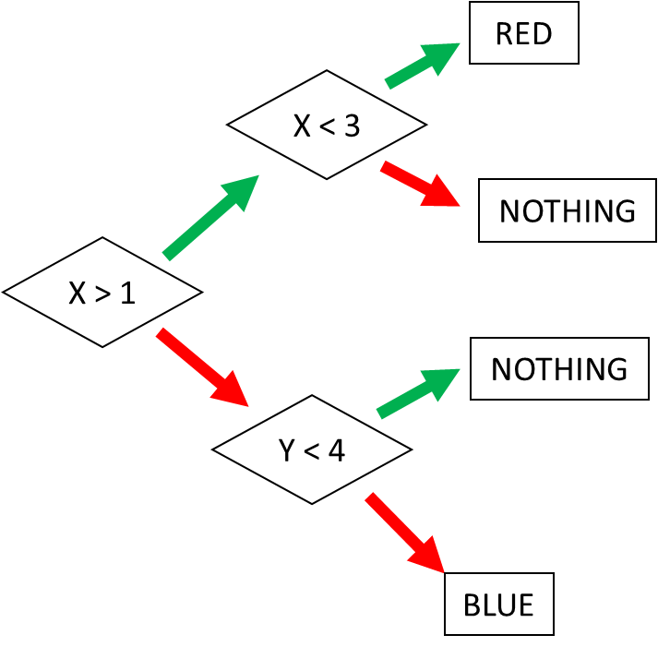 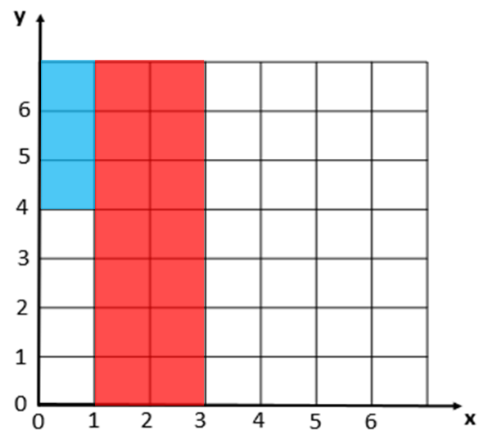

Ex 5: Square (1)

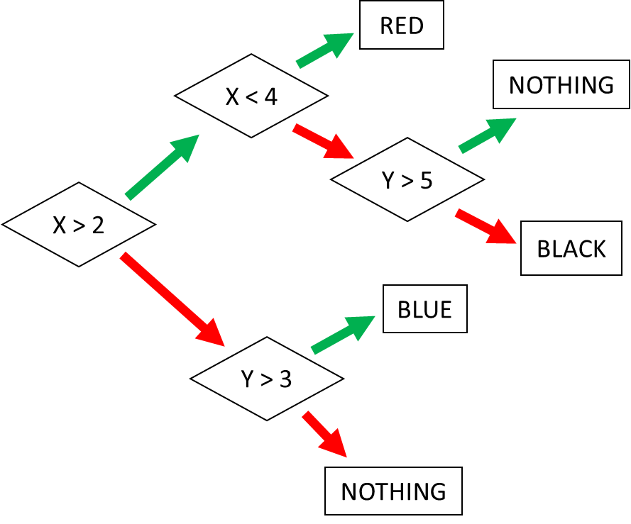 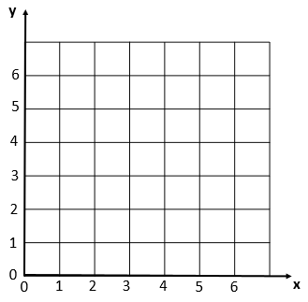

Ex 6: Square (2)

